Korntal-Münchingen, 2 November 2009

Two joint-sealing tapes added to the greenteQ line

Effective noise protection and rain impermeability with joint-sealing tapes from VBH

The greenteQ 600 and greenteQ 300 joint-sealing tapes represent a further extension of the greenteQ product line. The tapes, made of polyurethane foam with a dispersion impregnation of acryl, are available in various widths and lengths and offer an appropriate sealing and insulating solution for numerous application areas.

The greenteQ 600 joint-sealing tape already has been tested successfully according to DIN EN 18542:2009 before its introduction. With its proven joint noise reduction value of 59 dB, ift Rosenheim has endorsed the use of the BG1 tape. It is available in widths up to 18 mm and exhibits a so-called rain impermeability value of 600 pascal. It reliably insulates up to wind force 11 at a height of 100 m, and can be used universally for the sealing of connection and expansion joints in building construction. The preferred areas of use are window manufacture, prefabricated building and wall construction, woodwork as well as framework and concrete construction. With precompression, the sealing tape can also be used in existing joints.

A joint sealed with the 300 sealing tape withstands rain water with pressures of up to 300 pascal, which can be caused by wind, for example. The tape is available in widths from 2 to 12 mm and with these specifications, is particularly suited for the sealing of connection joints in the areas of window construction, facade technology, interior work or roof construction.

The greenteQ 600 und greenteQ 300 joint-sealing tapes are immediately available at VBH or can be obtained online in the customer portal www.vbh24.de.

Print-quality text and photos are available for download at www.vbh.de
Photo:

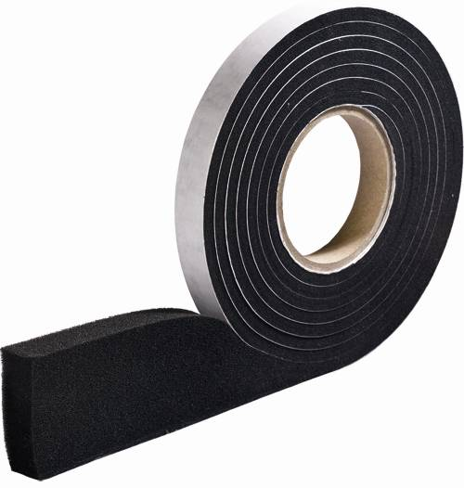

The greenteQ 600 joint-sealing tape reliably insulates up to wind force 11 and already has been successfully tested according to DIN EN 18542:2009 before its introduction.

