Korntal-Münchingen, (Germany) 09 September 2009
VBH is expanding the foam range of own brand greenteQ

New Pistol Foam with high Yield

The greenteQ 1K pistol GunFoam 500ml XXL B2 the hitherto assortment of the private VBH brand greenteQ by a year-round foam with a particularly high yield up to 45 litres, a high thermal conductivity and certified acoustic joint insulation.
With its consistent and fine-celled structure the one-component polyurethane foam is suitable for back filling and insulating sealing of connecting joints of windows or roller shutters as well as for the foaming of smaller wall openings and other hollows. The moisture-curing foam may be used at temperatures of -5 C° up to 20 C° and so it is appropriate as year-round foam. The consistently high discharge velocity as well as the short curing process allow for a comfortable handling: After from 6 to 8 minutes the foam is non-sticky, after from 8 to 10 minutes it can be cut and after 12 hours it is fully resilient. Furthermore doing without any greenhouse gases like FCKW or FKW saves our environment.
The quality of the product had been acknowledged and certified by the Materialprüfanstalt MPA BAU Hannover. At this opportunity the classification of building material class 2 was made, which classifies the pistol foam as a flammable building material with regular fire protection grade.
The greenteQ 1K pistol GunFoam 500ml XXL B2 is equipped with a threaded ring applicable for all dispensing guns. With immediate effect the product is available as a 12 can unit at VBH or online via the customer portal www.vbh24.de

Images and text are available for download at www.vbh.de.
Images:
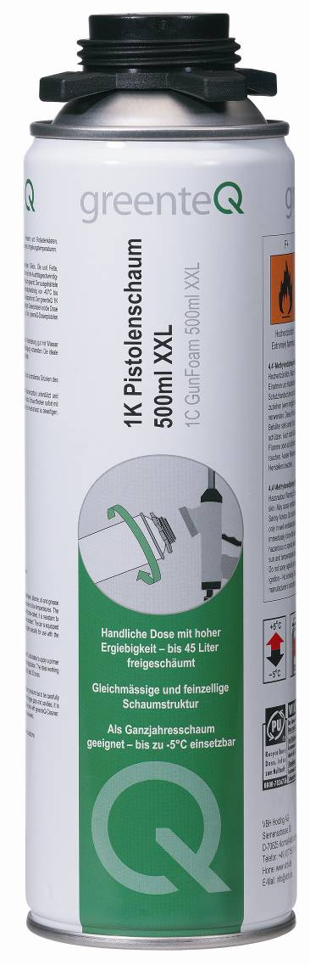 | The new 1K pistol GunFoam 500ml XXL B2 with a particularly high yield is suitable for back filling and insulating sealing of connecting joints of windows or roller shutters as well as for the foaming of smaller wall openings and other hollows.

