Korntal-Münchingen, 8. Oktober 2009
VBH extends its greenteQ brand range

Roller shutter motors extend greenteQ programme

In March 2009, VBH introduced its own greenteQ brand. The range of products now has been extended with new roller shutter motors in various installation sizes, with and without radio control.

The roller shutter motors permit roller shutters of various sizes to be cost-effectively motorised without a great amount of effort. The smallest variant, the greenteQ-Mini, is appropriate for systems with shaft diameters starting at 40 mm. For larger roller shutters with shaft diameters of 60 mm or more, the greenteQ-Micro and greenteQ-Ultra models are suitable. The Mini and Ultra models are additionally available with radio control, which makes operation of the roller shutters even more convenient. Connection and programming of the motors can easily be carried out with the instructions included. Afterwards, no maintenance is required.

All models also include an integrated thermostat that prevents damage due to overloading; the motor is automatically switched off when the maximum temperature is reached. Evidence of high quality is also shown by the 5-year guarantee that greenteQ offers for all defects caused by the manufacturer.

All described variants of the roller shutter motors are immediately available at VBH and in the online customer portal at www.vbh24.de.
Images:
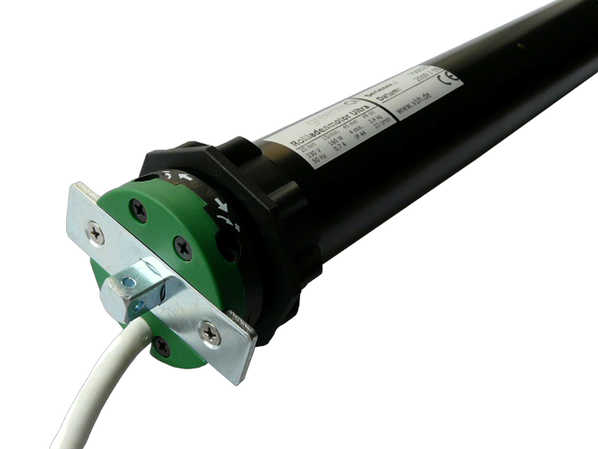 | New in the greenteQ product range from VBH: Roller shutter motors.
Print-quality text and artwork are available for download at www.vbh.de

