Korntal-Münchingen, 11 August 2009

Basic Products for Windows Construction and Installation

greenteQ – The New Own Brand of VBH

With its own brand greenteQ VBH is broadening the variety of goods by basic products for the daily requirements. Particularly when entering new markets European’s biggest business enterprise for windows and doors hardware sees its advantages. However also in future VBH will remain true to the strong partners and their branded products.

The focus of greenteQ is set on simple but top quality consumable products for windows construction and installation with a favourable cost performance ratio. Hence for the start into the world-wide markets various silicones, pastes and setting blocks are available. The name greenteQ derives from the brand’s colour green and the terms technique and quality. Nevertheless greenteQ shall not compete with the present strong brands.

„As a matter of course we will continue setting the focus on the branded products of our partners and their long-standing know-how. Any technically complex and advanced products like turn and tilt fittings or the like won’t be part of the product range of greenteQ,“ explains Markus Röser, Category Manager at VBH. With the new own brand VBH is merely extending the present basic products and will provide more flexibility for the international markets. Within the next five years VBH is expecting a percentage in sales of about 10 percent for greenteQ, in future 90 percent will still remain with the branded products. „For us it is important to enter new markets offering a broad product range right from the beginning and particularly products for which the quality management is up to us“, so Markus Röser.

Henceforth the present assortment may be reasonably completed by greenteQ as a best possible supplement for sections like windows and doors fittings, profiles, construction chemistry, building panels as well as tools and fastenings.

The text and the photos in high-resolution print quality are available for download under www.vbh.co.me
Photos:

The name of the new own brand of VBH greenteQ derives from the brand’s colour green and the terms technique and quality. The focus is set on consumable products for the daily requirements with a favourable cost performance ratio.
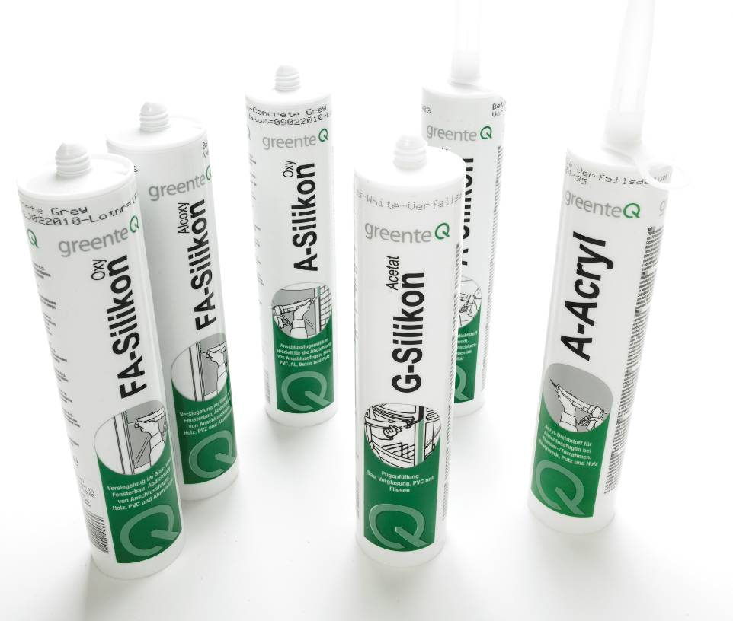
With its own brand greenteQ VBH is broadening the variety of goods by basic products for windows construction and installation. The brand shall complete the range of branded products of the partners.

